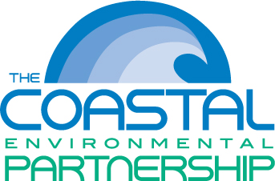 | Coastal Regional Solid Waste Management Authority  A Coastal Partnership Serving Carteret, Craven, & Pamlico Counties  7400 Old Hwy 70 West, New Bern, NC 28562  PO Box 128, Cove City, NC 28523  PH: (252) 633-1564 Fax: (252) 633-6515  www.cepnc.org

Hauler Permit & Credit Application MUST be completed in its entirety! There will be a $25 application fee due at the time of sign up.

Full Name: |  |  |  | Date:
 | Last | First | M.I.

Address:
 | Street Address | Apartment/Unit #

 | City | State | ZIP Code

Phone: |  | Email | :

Company Name: |  | Owner/Manager: |  | Payables Clerk/ PH#:

Type of Refuse:

Corporation: | YES | NO | Partnership: | YES | NO

Individual: | YES | NO

Have you ever had an account with us before? | YES | NO | If yes, when?

Number of trucks to access Landfill:

Truck Information
Make & Model: |  | Type:

Decal # |  | LCP#

Make & Model: |  | Type:

Decal # |  | LCP#

Make & Model: |  | Type: | _______________________________________________

Decal# |  | LCP#

Credit References
List only references of those from whom you purchase on open account, and current within the past two years. Fax Numbers MUST be included.
Contact Name: |  | Phone:
Email Address: _____  Company: |  | Fax:
Contact Name: |  | Phone:
Email Address:  Company: |  | Fax:
Contact Name: |  | Phone:
Email Address:  Company: |  | Fax:

Non-Resident Contractor
*NON-RESIDENT APLICANTS INCLUDE ALL AREAS WHO DO NOT HAVE A PHYSICAL ADDRESS/OFFICE LOCATION WITHIN CRAVEN, CARTERET, AND PAMLICO COUNTIES.
Company Name: |  | Phone:
Billing Office Address: |  | Supervisor:

Corporation? | YES | NO
If yes, State in which incorporated:

Is this credit application in relationship to a specific job or project? | YES | NO

Project Name: |  | Project Owner:
Site Location: |  | Owner Ph.#:

If MCAS Cherry Point project, please provide contract #:

Banking Institution
Name:

Contact:

Mailing Address:

Disclaimer and Signature
I am responsible for all company information submitted on this application. In addition, I authorize Coastal Regional Solid Waste Management Authority to investigate my credit responsibility through banks, credit reporting agencies and other financial sources.
(Submitting a Social Security Number speeds up the credit inquiry)
SS#:  Tax ID #:  Signature: |  | Date:

For Office Use Only

Reference Results:
Checked By:
Date:

